MANUSCRIPT TITLE IN ENGLISH (Times New Roman, 16 pt., bold, centered, all caps)

Academic rank, Scientific degree, Author’s Full Name (Times New Roman, 16 pt., bold, centered, in the case of a co-authored paper, each author should appear on a separate line with the same style and no line spacing)

Abstract: abstract in English up to 500 characters (Times New Roman, 12 pt., italics, double-sided alignment)

Key words: between 4 and 6 words (Times New Roman, 12 pt., italics, double-sided alignment)

JEL: JEL codes (Times New Roman, 12 pt., bold, double-sided alignment)

- Introduction (Times New Roman, 14 pt., bold, left alignment)
Content of introduction (Times New Roman, 14 pt., double-sided alignment).

- Title of the first paragraph (Times New Roman, 14 pt., bold, left alignment)
Contents of the first paragraph (Times New Roman, 14 pt., double-sided alignment). Graphs, diagrams and photographs should be formatted with the Wrap Text - In Line with Text option, with their names under the figure, with sequential numbers. The source of the figure must be indicated.

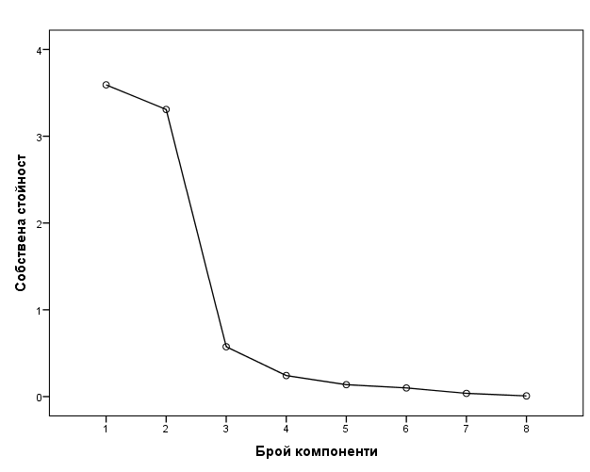
Figure. 1. Figure name (Times New Roman, 14 pt., italic, centred)
Source: www.nsi.bg (Times New Roman, 12 pt., italics, centered)

APA Style requirements are followed when citing.
Additional notes, clarifications and comments are made by footnote.

  - Title of first sub-paragraph (Times New Roman, 14 pt., italics, left alignment)
Contents of first sub-paragraph (Times New Roman, 14 pt., double- sided alignment).
When using tables to present data, assign a sequence number and name above the table. Indicate the source below the table.

Table 1. Number of new births in the "Creation and dissemination of information and creative products" sector (Times New Roman, 14 pt., italics, left alignment)
Type | 2017 | 2018
Limited liability companies and joint stock companies | 1898 | 1974
Partnerships and other legal forms | 33 | 59
Source: NSI (Times New Roman, 12 pt., italics, left alignment)

For the data in the table use Times New Roman, 12 pt. Bold font for the header. The table should be centred to the main text in the paragraph/sub-paragraph.
  - Title of second sub-paragraph (Times New Roman, 14 pt., italics, left alignment)
Contents of first sub-paragraph (Times New Roman, 14 pt., double-sided alignment). The number of paragraphs and sub-paragraphs (if any) in the statement is at the personal discretion of the author.

- Title of the second paragraph (Times New Roman, 14 pt., bold, left alignment)
Contents of the first paragraph (Times New Roman, 14 pt., double-sided alignment).
Formula reference numbers are denoted by a number to the right of them in small brackets.
(1)

- Conclusions (Times New Roman, 14 pt., bold, left alignment)
Content of the conclusion (Times New Roman, 14 pt., double-sided alignment).

References (Times New Roman, 14 pt., bold, left alignment)
The list of references cited is formatted according to APA Style requirements (Beins, 2012). The order of the references is alphabetical, with those in Cyrillic first (Times New Roman, 12 pt., left alignment).

Bogdanova, M. (2020). University business models in crisis management. Business management (4), 37-48.
Beins, B. (2012). APA Style Simplified: Writing in Psychology, Education, Nursing, and Sociology. New York: Wiley-Blackwell.

Additional notes, explanations and comments (Times New Roman, 12 pt., double-spaced, single-spaced).

